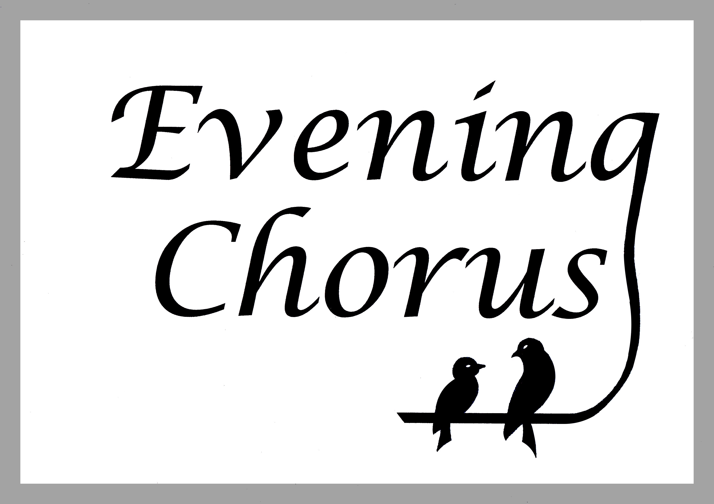

**An Evening Chorus**

**WORKSHOP**

Come and join us for what will be an informative, entertaining and enjoyable day. We will take part in fun warm-up exercises, learn about different aspects of singing, and work on songs from the hit show Oliver! (now in the West End). We will be led again by Julia Whitbread, Director of Music at Bancroft’s School.

**Date:** Saturday 8th March 2025

**Time:** Registration from 10.30am, workshop 11am–3pm, sing-through 3.30pm

**Address:** Preparatory School Hall, Bancroft’s School. For directions see [www.eveningchorus.org/contact](http://www.eveningchorus.org/contact)

Please note this workshop is for female soprano/alto voices only.

**Julia Whitbread**

Julia Whitbread studied singing and piano at the Royal Academy of Music. As well as performing for Choral Societies and giving recitals, much of her career has been in education working in two schools: RMS for Girls in Rickmansworth and now as Director of Music at Bancroft’s School. She is also an examiner for ABRSM. Julia really enjoys choral music and being able to facilitate groups of singers to take part in large scale choral works such as: The Armed Man by Karl Jenkins and Requiem by Faure, both at Bancroft’s. Julia truly believes that everyone can sing!

**Parking** on-site parking is available – you can also park on surrounding roads. Buses 20 and 179 stop outside the school.

**Cost:** **Guests £22 per person** (music included) Tea/coffee/biscuits provided – (please bring your own lunch and water)

Members of Evening Chorus Choir and Sixth-form students of Bancroft’s School will be charged **£12 per person.**

**Choir payment:** By Bank Transfer (preferred). Cash or cheque (made payable to ‘Evening Chorus’ and handed to Lesley Graham

**Guest Payment: If you would like to join us, please detach this page and return it with your payment to a choir member or:**

**Evening Chorus**

**Magnolia Cottage**

**Silver Birch Avenue**

**North Weald**

**Essex CM16 6 LB**

**Name:………………………………………………………………………………**

**E-mail Address: ……………………………………………………………………………………….**

**Phone Number…………………………………………………………………………….**

**Please circle your preferred part:**

**SOPRANO 1**

**SOPRANO 2**

**ALTO**

**Cheques should be made payable to ‘Evening Chorus”**

**To pay by bank transfer please contact Lesley Graham at lesley.graham07@gmail.com** **for bank details**

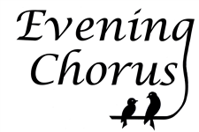**www.eveningchorus.org**